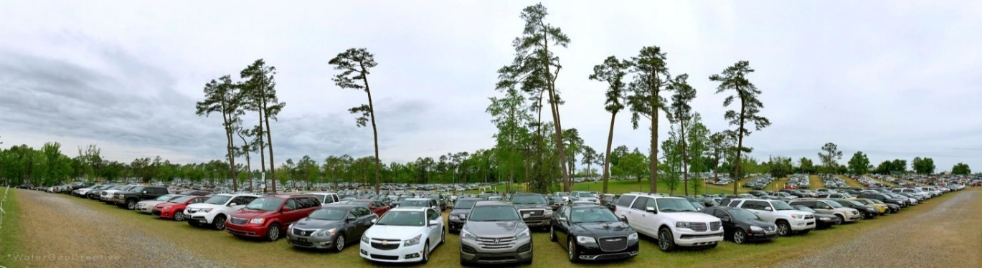

If you are an avid sports fan, we have a great opportunity for you to be a part of one of the world's finest sporting events. We are hiring Parking Attendants to work with us at the 2026 Masters Tournament. The event will take place at the Augusta National Golf Club beginning Saturday, April 4, and continuing through Sunday, April 12, 2026.

- Morning and afternoon shifts
- Competitive pay
- Must be 15+ years of age
- Overtime after 40 hours
If interested in applying, please scan the QR code below:
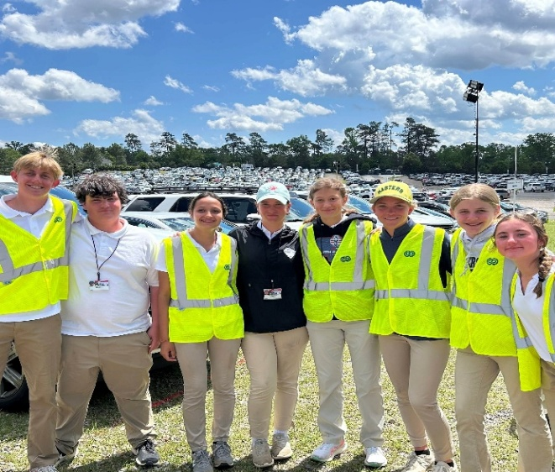
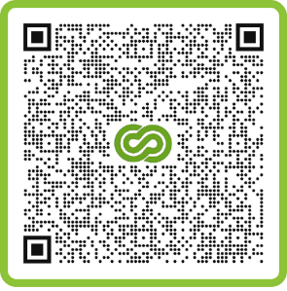
You may also visit our office to apply:
2623 Washington Rd, Building A, Suite 102
Augusta, GA. 30909

Additional opportunities for interested Parents, Teachers, and staff are available as Greeters or qualified Drivers. If there are any issues throughout the application process, please feel free to call us at 706-733-7175.

